**Topic 2**

**INVENTORY MANAGEMENT**

**Inventory management**

Inventory could be defined in many ways. However, for this purpose, the definition shall be stock oriented:

Inventory could be defined as the stock of economic items, which are needed for further use, consumption or sales. Since they are held for further usage, the capital invested is also tied down. As such, there is need for management, to ensure that optimum inventory is kept, so as to minimise total inventory management cost.

Besides, inventory could also be defined as an idle stock that awaits usage, consumption or sales. It is called idle because it’s not yet consumed or used for the purpose(s) in which it was held.

# **Objectives of Inventory Analysis**

We carry out inventory analysis to know the optimum stock of items to be held per time, to avoid the problems of over or under stocking and consequently minimises the total inventory management cost. The optimum quantity to be held is otherwise called Economic Order Quantity (EOQ).

**Costs Inventory Costs**

The various costs of inventory are

* + - 1. Purchase Costs: These are the costs of acquiring the items held.
      2. Ordering Recorder Costs: These are the costs of requisition or placing order and bringing the stocks into usable or sellable form. The costs that are associated with these are; paper and clerical costs of placing order, loading and unloading costs, transportation costs, Stock taking costs, and so on.
      3. Holding or Carrying Costs: These are the cost of storing items. That is, keeping the stock until it is needed for use. The costs under this are; insurance costs, Deterioration prevention costs, warehousing costs, security costs, cooling or heating costs, pilferage costs, costs of capital tied down, obsolescence prevention costs, and so on.
      4. Stock out or shortage costs: These are the costs of running out of stock. This includes; costs of good will lost, cost of sales lost, sub-contracting costs, and so on.

**What are the basic questions, which inventory analysis, is out to solve?**

The questions which inventory analysis is out to provide solutions are:

What is the optimum quantity of an item to order each time?

When should order be made?

What level should stock get down to, (safety stock) before requisitions are placed?

How much shortage should be allowed?

**Assumptions of the Basic Economic Order Quantity (EOQ) Model**

The Economic Order Quantity (EOQ) provides answers to the optimum quantity of stock to keep, to avoid over or under stocking with the following assumptions:

1. That, the rate of periodic demand is known and does not change.

2. That, the rate of replenishment is instantaneous. That is, supply is effected immediately orders are made.

3. Inventory is allowed to go down to zero level. That is no safety stock.

4. The periodic unit price is known and does not change.

5. Carrying or holding costs vary linearly and directly with the size of the items.

6. That, there is no stock out, hence, no stock out cost.

**Costs associated with over stocking of items in organisation**

The associated costs of over stocking of items in organisations are numerous. However, some are:

1. Risk of obsolescence
2. Cost of capital tied down
3. Pilferage costs
4. Cost of holding additional stock.

**problems of under stocking**

1. Costs of good will lost. That is, when there is stock out.
2. Costs of paying workers for jobs not done when there is no stock to meet up with customer’s demands.
3. Costs of sub-contracting to meet up with customers’ demand.
4. Cost of firing staff when stock out is experienced and hiring new ones when there is stock.

**Example 1**

As an analyst, a company has an annual demand of 60,000 units, the handling and cost of

phoning each time order is made amount to ~~N~~50, the unit price is known to be ~~N~~60 and the

storage cost including insurance premium amount to 15½%.

You are required to analyse and advise the company on:

1. The Optimum units to keep per time.
2. The total cost.
3. Time to order.

## SOLUTION

1. The optimum unit is the Economic Order Quantity (EOQ).

EOQ formula = 2DRc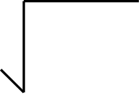

Hc

Where;

D = Annual demand = 60,000 units

Rc = Ordering cost = ~~N~~50

Hc = Holding cost = 15.5%

P = price per unit = ~~N~~60

Note that Hc = (0.155 x ~~N~~60) = ~~N~~9.3

∴ EOQ = 2 x 60,000 x ~~N~~50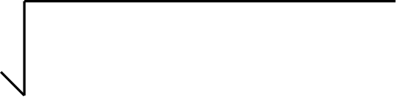

~~N~~9.3

EOQ = 6,000,000 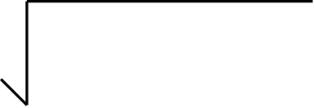

~~N~~9.3

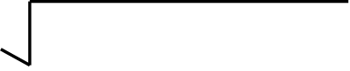

= 645161.29

∴ EOQ = 803.22 units

Therefore, the optimum units that the company should order per time is 803.22 units

1. The total cost:

TC = PD + QHc + DRC

1. Q

TC = ~~N~~60(60,000) + 803.22 x ~~N~~9.3 + 60,000 x ~~N~~50

2 803.22

TC = ~~N~~3,600,000 + ~~N~~7469.946 + ~~N~~3,000,000 

1. 803.22

TC = ~~N~~3,600,000 + ~~N~~3734.97 + ~~N~~3734.97

∴ TC = ~~N~~3,607,469.94

∴ The total cost for the company is ~~N~~3,607,469.94

3. The optimum time to order:

* The annual demand = 60,000 units
* The optimum order per time (Q) = 803.22 units
* The number of time (T) order should be place is

T = D = 60,000 units

Q 803.22

= 74.699

Appr. 74.70 times/year

∴ If the working days in a year is assumed to be 365 working days, the company should place order every;

Working days/year = 365

Times (T) 74.70

= Approximately 4.89 days

**SUB-TOPIC**

**INVENTORY MODEL WITH QUANTITY DISCOUNTS OR VARIABLE DEMANDS**

A discount is when seller to induce customers to buy more than their normal Economic Order Quantities reduces prices of goods. When this occurs, the assumption of the basic EOQ that price per unit remain constant is relaxed, due to the effects of the discount offered. Then, the problem now arises as to whether to accept or reject discount offered. Well, to answer this question requires a rigorous exercise of considering the costs associated with the Basic EOQ and compare it with the cost of each succeeding discount point, so as to know the best quantity to order per time.

Besides, discount is always associated with both benefits and negative effects;

1. Benefits; lower price per unit of item and reduced numbers of orders.
2. Negative effects: increases in stock holding cost.

## QUESTION

6.11 Company XYZ has an annual demand of 4200 units, ordering cost per order of ~~N~~6.60, a stockholding cost of 22% of the unit price and XYZ has a discount opportunity of the following:

| Units | Price/unit |
| --- | --- |
| Less than 250 | ~~N~~6.40 |
| 250 to 800 | ~~N~~6.00 |
| 801 to 2000 | ~~N~~5.90 |
| 2001 to 4000 | ~~N~~5.80 |
| 4001 and above | ~~N~~5.50 |

You are required to choose among the discount offered to XYZ, so as to minimise the total cost.

### SOLUTION

EOQ of first price range = 2DRc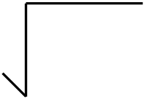

Hc

Where;

D = Annual demand = 4200 units

Rc = Reorder cost = ~~N~~6.60

Hc = Holding cost = 22% of price/unit

P = Price per unit/year =

For price ~~N~~6.40:

∴ EOQ = 2 x 4200 x ~~N~~6.60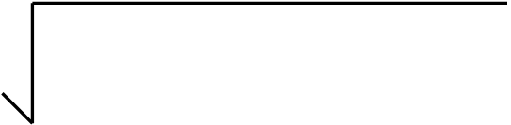

~~N~~6.40 x 0.22

= 55440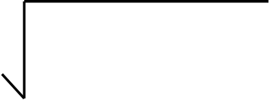

1.408

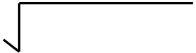

= 39375

∴ EOQ = 198.43 units

Calculate the Total cost using the 198.43 as your Q* since it falls within the feasible region;

Tc = PD + Q*Hc + DRc

# Q*

Where:

Hc = 0.22 x ~~N~~6.40 = ~~N~~1.408

TC = ~~N~~6.40(4200) + 198.43 x ~~N~~1.408 + 4200 x ~~N~~6.60

2 198.43

TC = ~~N~~26880 + ~~N~~139.70 + ~~N~~139.70

∴ TC = ~~N~~27,159.40

For price ~~N~~6.00:

∴ EOQ = 2 x 4200 x ~~N~~6.60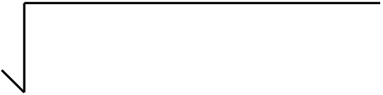

~~N~~6.00 x 0.22

= 55440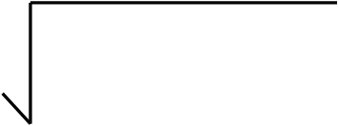

~~N~~1.32

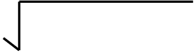

= 42,000

∴ EOQ = 204.94 units

Since the EOQ falls below the feasible region, use the lower limit of the quantity range as your Q* to calculate your Total cost as follows:

O* = 250 units

Tc = PD + Q* x Hc + DRc

# 2 Q*

TC = ~~N~~6(4200) + 250 x ~~N~~1.32 + 4200 x ~~N~~6.60

2 250

TC = ~~N~~25,200 + ~~N~~165 + ~~N~~110.88

∴ TC = ~~N~~25, 475.88

For price ~~N~~5.90:

∴ EOQ = 2 x 4200 x ~~N~~6.60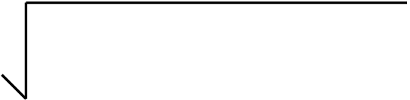

~~N~~5.90 x 0.22

= 55440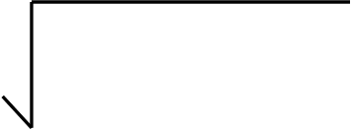

1.290

∴ EOQ = 207.31 units

Still, EOQ falls below the feasible region, therefore, use the lower limit of the quantity range as Q* to calculate your Total cost. (i.e 801 units).

Tc = PD + Q* x Hc + DRc

# 2 Q*

= ~~N~~5.90 x4200 + 801 x ~~N~~1.290 + 4200 x ~~N~~6.60

2 801

TC = ~~N~~24,780 + ~~N~~516.65 + ~~N~~34.61

∴ TC = ~~N~~25,331.26

For price ~~N~~5.80:

∴ EOQ = 2 x 4200 x ~~N~~6.60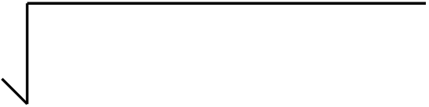

~~N~~5.80 x 0.22

= 55440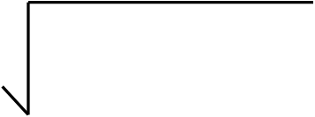

~~N~~1.276

∴ EOQ = 208.44 units

Therefore use 2001 as your Q* to calculate your Total cost as follows:

Tc = PD + Q* x Hc + DRc

# 2 Q*

TC = ~~N~~5.80(4200) + 2001 x ~~N~~1.276 + 4200 x ~~N~~6.60

2 2001

TC = ~~N~~24,360 + ~~N~~1,276.64 + ~~N~~13.85

∴ TC = ~~N~~25, 650.49

For price ~~N~~5.50:

∴ EOQ = 2 x 4200 x ~~N~~6.60

~~N~~5.50 x 0.22

= 55440

~~N~~1.21

∴ EOQ = 214.05 units

Since the EOQ falls below the feasible region, again use 4001 as Q* to calculate your Total cost:

Tc = PD + Q* x Hc + DRc

# 2 Q*

TC = ~~N~~5.50(4200) + 4001 x ~~N~~1.21 + 4200 x ~~N~~6.60

2 4001

TC = ~~N~~23,100 + ~~N~~2420.61 + ~~N~~6.91

∴ TC = ~~N~~25, 527.52

**Conclusion**: The minimum total costs of the entire discount offered to XYZ occurred at price ~~N~~ 5.90. The Q* used at that point is 801 units = ~~N~~ 25,331.26 which is far below others.

Therefore, XYZ should order 801 units each time, as that is the optimum quantity that will minimise its total cost.

**Note** the following points about the question and solution above:

1. When EOQ is calculated, if it is below the quantity range (below feasible region) choose the lower limit to calculate your total cost.
2. If the EOQ calculated is within the feasible region, use the EOQ calculated, to calculate your total cost.
3. On the other hand, if the EOQ is above the quantity range, discard it away as not reasonable, and do not calculate such quantities’ total cost.

Note that, the above question and solution could be put into a graph and table to explain some of the effects of quantity discount on;

1. Ordering cost
2. Holding cost
3. Total cost

| A  Order quantity (units) | B  Price/ unit (~~N~~) | C Inventory purchase cost (A x B) ~~N~~ | D Annual ordering cost ~~N~~ | E  Holding cost per  Annum ~~N~~ | F (C + D + E) Total cost ~~N~~ |
| --- | --- | --- | --- | --- | --- |
| 4,200 | 6.40 | 26,880 | 139.70 | 139.70 | 27,159.40 |
| 4,200 | 6.00 | 25,200 | 110.88 | 165 | 25,475.88 |
| 4,200 | 5.90 | 24,780 | 34.61 | 516.65 | 25,331.26* |
| 4,200 | 5.80 | 24,360 | 13.85 | 1276.64 | 25,650.49 |
| 4,200 | 5.50 | 23,100 | 6.91 | 2420.61 | 25,527.52 |

The above table represents the relationships among price discount at various levels and the consequences on the inventory cost, as a result of price reduction; The effect on ordering cost due to increases in quantity ordered per time and the consequent reduction of numbers of orders; increases in total holding cost due to increases in quantity, so as to enjoy from the quantity discount and the total cost of both the inventory management cost plus the inventory purchase cost.

From the above table, all the various quantities levels were compared, and **~~N~~ 25,331.26** was recommended for XYZ.